2017
PS 24 Queens Andrew Jackson Elementary

Debra Cassidy, Principal

NEW IMMIGRANT RESOURCES

141-11 Holly Avenue, Queens, NY 11355 (718) 359-2288

New Immigrant Resources
PS 24 is a multicultural public school that celebrates diverse cultural backgrounds.
We help our recent immigrants through a series of workshops and services so that they may better navigate their way in New York City.
Success with our students begin with a strong partnership with their parents and guardians by helping them to understand how best to support their children and to introduce them to the many services and venues available to them.
This booklet is a summary of local resources that we hope will enable new immigrants thrive in their new home.
Welcome to our neighborhood!
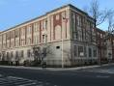

Local Hospitals
- NewYork-Presbyterian/Queens
Website: http://www.nyhq.org
Phone: (718) 670-2000 (800) 282-6684
Address: 56-45 Main Street, Flushing, NY 11355

- Flushing Hospital Medical Center
Website: flushinghospital.org
Phone: (718) 670-5000
Address: 4500 Parsons Blvd, Flushing, NY 11355

- NYU Langone Cardiovascular Associates
Website: http://nyulangone.org
Phone: 718-353-4004
Address: 142-42 Booth Memorial Avenue
1st Floor, Flushing, NY 11355
Phone: (718) 423-3355
Address: 143-51 Roosevelt Avenue
Suite 1A, Flushing, NY 11354

- First Med Immediate Medical Care
Website: http://www.firstmedny.com
Phone: (718) 224-8855
Address: 191-20 Northern Blvd., Flushing, NY 11358

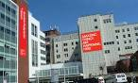
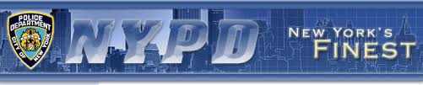
Local Police Station

- New York City Police Department 109th Precinct
Website: http://www.nyc.gov/html/nypd/html/
precincts/precinct_109.shtml
Address: 37-05 Union Street, Flushing, NY 11354
Phone: (718) 321-2250

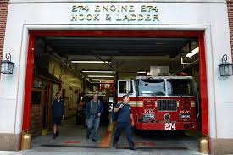

Local Fire Department
- FDNY Engine 274
Address: 41-20 Murray Street, Flushing, NY 11355

Local Libraries

Local Library branches offer free programs related to work and life skills development, as well as cultural and recreational presentations through local partnerships, volunteers, or contracted performers for people of all ages.
The Library helps non-English speaking immigrants understand and interact with the culture, government, and educational system of the United States, via resources and services offered.
- Queens Library at Flushing
Website: www.queenslibrary.org/flushing
Address: 41-17 Main St, Flushing, NY 11355
Phone: (718) 661-1200

- Queens Library at Queensboro Hill
Website:www.queenslibrary.org/branch/queensboro-hill
Address: 60-5 Main St, Flushing, NY 11355
Phone: (718) 359-8332

- Queens Library at Mitchell-Linden
Website: www.queenslibrary.org/mitchell-linden
Address: 31-32 Union St, Flushing, NY 11354
Phone: (718) 539-2330

- Health Education Library
Website: www.healthlibrary.com
Address: 56-45 Main St, Flushing, NY 11355
Phone: (718) 670-1118

Local Museums
- Queens Historical Society
The Queens Historical Society is dedicated to preserving the history of Queens through educational program and exhibitions.
Website: www.queenshistoricalsociety.org
Address: 14335 37th Avenue, Flushing, NY 11354
Phone: (718) 939-0647

- Voelker Orth Museum
The Voelker Orth Museum, Bird Sanctuary and Victorian Garden is a New York City Landmark. The Voelker Orth Museum engages audiences through the arts, education, nature, horticulture and local history by offering house tours, exhibitions, concerts, lectures and workshops, cultural festivals, and family and school programs.
Website: www.vomuseum.org
Address: 14919 38th Ave, Flushing, NY 11354
Phone: (718) 359-6227

- Lewis Howard Latimer House Museum
The Lewis H. Latimer House, was constructed in the Queen Anne style of architecture between 1887 and 1889y.
Website: historichousetrust.org/house/lewis-h- latimer-house-museum
Address: 34-41 137th St, Flushing, NY 11354
Phone: (718) 961-8585

- Queens Museum
The Queens Museum is an art museum and educational center located in Flushing Meadows-Corona Park.
Website: www.queensmuseum.org
Phone: (718) 592-9700
Address: Flushing Meadows Corona Park, New York City Building, Queens, NY 11368

- New York Hall Of Science
The New York Hall of Science, also known as NYSCI, is a science museum located in Flushing Meadows-Corona Park.

Website: nysci.org
Address: 47-01 111th St, Corona, NY 11368
Phone: (718) 699-0005
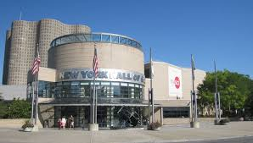

- Louis Armstrong House Museum
The Louis Armstrong House was the home of Louis Armstrong and his wife Lucille Wilson from 1943 until his death in 1971. Lucille gave ownership of it to the city of New York in order to create a museum focused on her husband.

Website: www.louisarmstronghouse.org
Address: 34-56 107th St, Flushing, NY 11368
Phone: (718) 478-8274

- Flushing Town Hall
Flushing Town Hall is a historic Town Hall located in the Flushing section of the New York City borough of Queens.

Website: http://www.flushingtownhall.org
Address: 137-35 Northern Blvd, Flushing, NY 11354
Phone: (718) 463-7700

Local Attractions
- NYC Dept. of Parks & Recreation
Website available in multiple languages:
https://www.nycgovparks.org/index.php
Go to “Translate” to select your preferred language and check out the special events and activities available for the family in the NYC area.

- Queens Botanical Garden
The Queens Botanical Garden began as part of the 1939 New York World's Fair in Queens. The garden expanded to take up a larger portion of Flushing Meadows Park.
Website: www.queensbotanical.org
Address: 43-50 Main Street, Flushing, NY 11355
Phone: (718) 886-3800
Tickets: Adults – $6, Seniors (age 62+) – $4,
Students with ID – $4, Children (ages 4 to 12) – $2, Children (3 and under) – FREE, Members – FREE

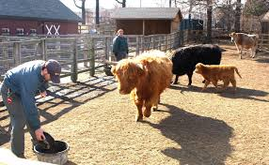
- Queens Zoo
Exhibits: Aviary, Woodland Trail,
South American Trail,
Sea Lion Pool, Great Plains,
Waterfowl Marsh, Domestic Animals

Website: https://queenszoo.com
Address: 53-51 111th Street, Corona, NY 11368
Phone: (718) 271-1500
Tickets: Adult 13 & over - $8, Child 3 to 12 - $5,
Senior 65 & over - $6, Child 2 & under - FREE

Local Department Stores & Shopping Malls
- The Shops at Skyview Center, Shopping Mall

Nordstrom, Marshalls, Target and more!
Address: 40-24 College Pt. Blvd., Flushing, NY 11354

- Macy's Department Store
Department store chain providing brand-name clothing, accessories, home furnishings & housewares.

Website: http://www1.macys.com
Address: 136-50 Roosevelt Ave., Flushing, NY 11354
Phone: (718) 358-9000

- Fresh Meadows Shopping Center
Shopping Mall
Address: 61-18 190th Street, Queens, NY

- Golden Shopping Mall
Complex with varied Chinese merchants
Address: 41-36 Main Street, Flushing, NY

- New World Mall
Indoor mall with an Asian market & cafes
Address: 136-20 Roosevelt Avenue, Flushing, NY

- The Shops at Queens Crossing
Shops & restaurants with Asian focus
Address: 136-17 39th Avenue, Flushing, NY

- Flushing Town Center LP
Shopping Mall
Address: 4024 College Point Boulevard, Flushing, NY

Government Agencies

- Mayor’s Office of Immigrant Affairs
Immigration legal services, City services & other benefits
Website available in multiple languages:
http://www1.nyc.gov/site/immigrants/index.page
Phone: (212) 788-7654
- US Post Office – Flushing Branch
Postal Services; Passport Services
Address: 4165 Main Street, Flushing, NY 11355
Website: https://www.usps.com
Phone: (718) 321-6893
- Social Security Offices
Queens Social Security Card Center
Address: 155-10 Jamaica Avenue, Queens, NY
Phone: (800) 772-1213
- Social Security Office
Address: 31-08 37th Avenue, Flushing, NY
Phone: (800) 772-1213
- Department of Motor Vehicles
168-46 91st Avenue, Jamaica, NY 11432
Website available in multiple languages: dmv.ny.gov
- Department of Youth & Community Development
For Youth, Adults, Families & Seniors
Website available in multiple languages:
http://www1.nyc.gov/site/dycd/services/services.page
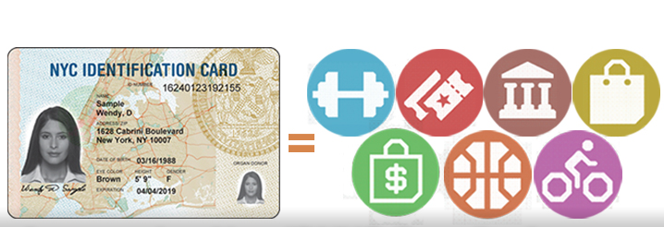

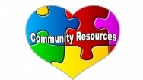
New York City Department of Education
Website: http://schools.nyc.gov/default.htm

Information is available in many languages, select your preferred language from the drop down menu located on the top right hand corner of Webpage.
, , , , , ,
,
Parents & Families Website: http://schools.nyc.gov/ParentsFamilies/default.htm
DOE Academics Website:
http://schools.nyc.gov/Academics/default.htm

OACE – Office of Adult and Continuing Education
New York City residents 21 years or older may register for classes anywhere in the city. All classes are taught by certified teachers and are tuition-free. PS 24 is a site of the Adult English language program offered on Saturdays; 8:30am–12:30pm.
Website is available in multiple languages:
http://schools.nyc.gov/community/AdultEd/default.htm

Family Welcome Center
30-48 Linden Place, 2nd Floor, Flushing, NY 11354

Suggested Resources to Support Reading for Students
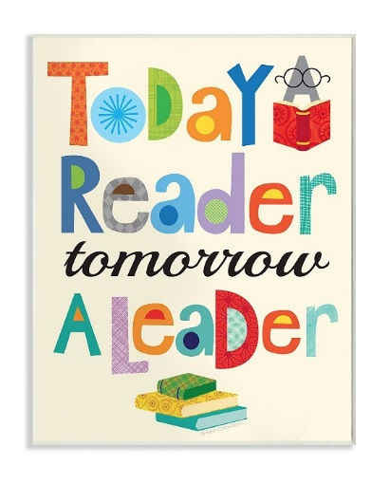

nycs.benchmarkuniverse.com
Thinkcerca.com
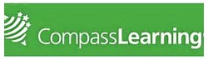
Follet.com
Compasslearning.com

Check Grades and Attendance
Visit: mystudent.nyc to log in.
Contact Parent Coordinator to help set up an account.

PS 24 Queens
141-11 Holly Avenue
Flushing, NY 11355
Telephone: (718) 359-2288 Fax: (718) 460-3251

School Website: www.ps24queens.weebly.com

Principal
Debra Cassidy DCassid3@schools.nyc.gov

Assistant Principals
Joann Montoya JMontoya@schools.nyc.gov
Renee Klager RKlager@schools.nyc.gov
Saher Said SSaid@schools.nyc.gov
Bani Singh BSingh@schools.nyc.gov

Guidance Counselor
Ellen Hochberg EHochbe@schools.nyc.gov

Youth Developer
Anita Leiter ALeiter@schools.nyc.gov

School Based Support Team
William Luo wluo@schools.nyc.gov

Parent Coordinator
Lu Yin LYin@schools.nyc.gov

